Project Two: Summary and Reflections Report

Summary: Testing Approach and Results
For Project One, I developed and tested three parts of a mobile application: contacts, tasks, and appointments. I used JUnit tests to check the requirements for each class and service. My goal was to make sure the application accepted correct information and rejected information that did not follow the rules. I tested normal actions and incorrect inputs instead of checking only whether the program could run.
For contacts, I tested creating records, updating information, deleting records, and preventing duplicate IDs. ContactTest.java includes tests for names that are too long, phone numbers with the wrong number of digits, and null values. For example, testPhoneOnlyDigits checks that a phone number containing invalid characters is rejected. ContactServiceTest.java checks that adding a duplicate contact ID causes an exception and that updating a contact keeps its ID unchanged.
For tasks, I tested the limits for task IDs, names, and descriptions. I also checked adding, deleting, and updating tasks. In TaskServiceTest.java, testUpdateName and testUpdateDescription confirm that the requested changes are saved. The tests for an invalid task ID confirm that the service does not silently update a record that does not exist. For appointments, I tested the ID and description limits, null values, and dates in the past. AppointmentServiceTest.java checks adding an appointment, rejecting duplicate IDs, and deleting appointments.

Effectiveness and Code Quality
My Eclipse JUnit results showed 50 tests completed, with zero failures and zero errors. The coverage report showed 88.3% instruction coverage across the project: 1,361 covered instructions out of 1,541. Task.java and AppointmentService.java each reached 100% instruction coverage. TaskService.java reached 99.3%, and ContactService.java reached 96.2%. Appointment.java had the lowest coverage at 63.6%. These results support that many important requirements were tested, but they do not prove that the program has no defects. The screenshots at the end of this report show the actual results.
I tried to keep the tests technically sound by checking the expected result instead of only calling a method. For example, TaskServiceTest.java uses assertEquals after updating a task name, while AppointmentTest.java uses assertThrows(IllegalArgumentException.class, ...) for an appointment date in the past. These checks make it clear what should happen. I also used separate test methods for different rules, so a failed test would be easier to identify and correct.
I kept the tests efficient by using small sample records and focusing each test on one behavior. ContactServiceTest.java uses a setUp method to create a fresh service before tests, which helps prevent earlier test data from changing later results. This is useful because tests should be repeatable. I could improve efficiency further by reducing repeated setup code where it does not make the tests harder to understand.

Reflection: Testing Techniques
The main technique I used was unit testing. Unit tests check small parts of the application, such as a constructor, a setter, or a service method. I also used positive testing for valid inputs and negative testing for invalid inputs. Boundary testing was important because the requirements included maximum lengths and a ten-digit phone number. For example, my tests checked values that were too long and invalid phone numbers. I used exception testing to confirm that invalid data caused the expected IllegalArgumentException.
I did not build a full user-interface test or a performance test. UI testing would be useful for checking buttons, forms, and navigation in a complete mobile application. Integration testing would help confirm that the contact, task, and appointment parts work correctly with a database or other connected services. Performance testing would be more important if the application needed to support many users or large amounts of data. Security testing would also matter if the application stored private customer information.

Reflection: Mindset, Caution, and Bias
While writing tests, I learned that it is important to question my own code. A developer might assume a method works because the normal example passes. I tried to avoid that mistake by testing null values, duplicate IDs, missing records, and invalid dates. I also compared my tests with the written requirements rather than deciding that the code was correct just because it compiled. The lower coverage in Appointment.java shows that I still have room to improve. I would review the uncovered lines and add tests for any meaningful behavior that was missed.
I think being careful and disciplined is part of being a responsible software developer. Small errors can affect real users after a program is released. In future projects, I plan to run the complete test suite after changes, review coverage, and investigate failures before releasing code. I also want to remember that high coverage is useful evidence, but it cannot replace thoughtful test cases. Overall, this project helped me understand how testing supports software quality and why developers need to keep checking their assumptions.

Evidence: Eclipse Test and Coverage Results
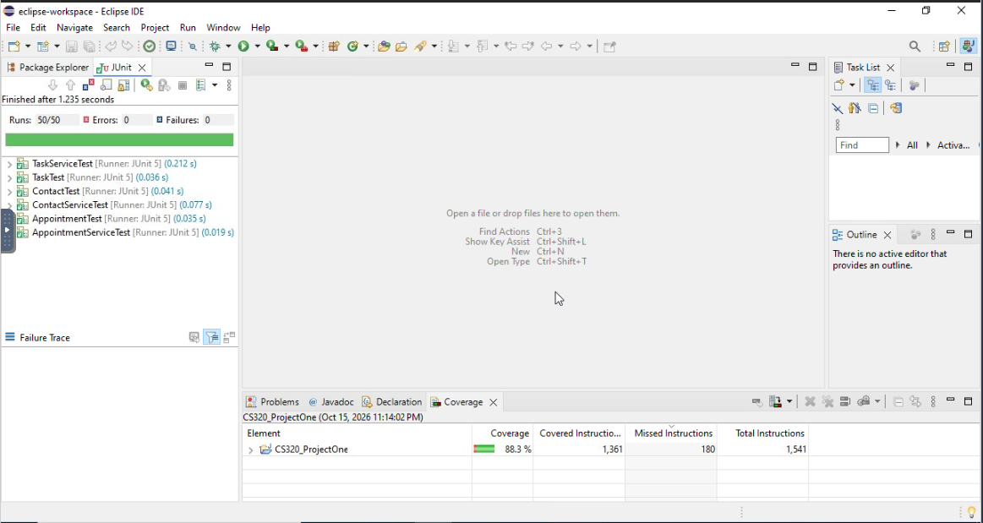
Figure 1. JUnit results: 50 tests passed, no failures or errors.
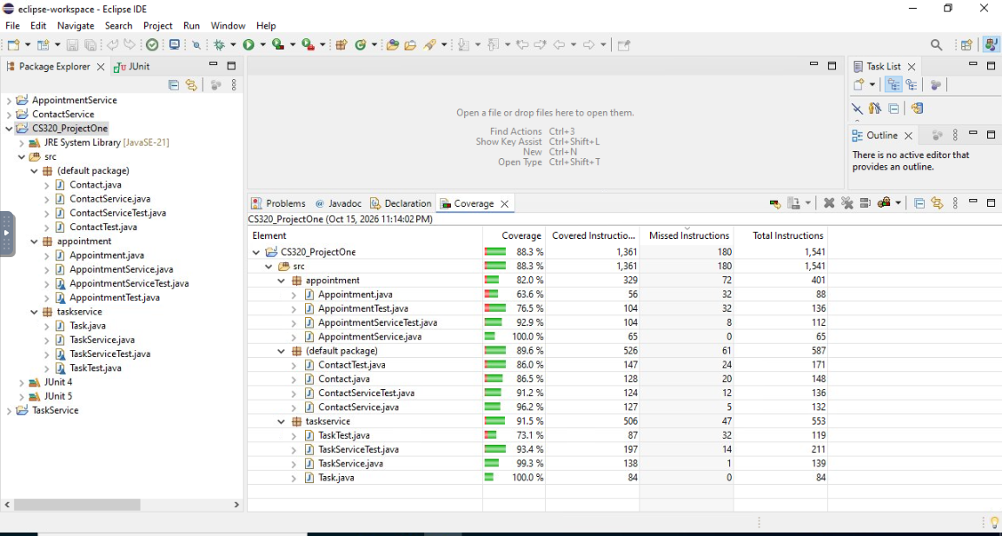
Figure 2. Eclipse instruction coverage by class (88.3% overall).
Source note: Test examples and screenshots come from my CS320_ProjectOne Java project and Eclipse JUnit/coverage results. No outside sources were used.

